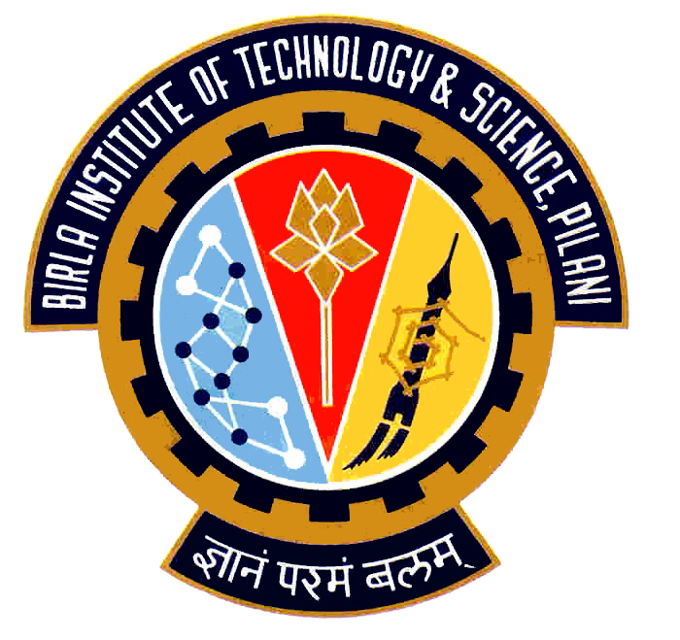

Election Commission

Birla Institute of Technology & Science – Pilani, Goa Campus, Zuarinagar, Goa-403726, INDIA
Tel: (0)98233 6368 Fax:0832-2557033

Final List of Candidates for Hostel Representatives:

CH 3
CULTURAL
CHAVALI VAMSI RAM | 2007S1P8490
TEJASVA DHYANI | 2007P3PS127
HOSTEL AND CAMPUS MANAGEMENT
PONDURU VARUN PRASAD | 2007S3P8647
VINEET KUMAR MITTAL | 2007P1PS458
AKASH TEKCHANDANI | 2007P1PS751
AASHISH JAIN KOTHARI | 2007T6PS338
MESS
TATWAWADI PRANAV VINAY | 2007T6PS514
G. ANANTH RAGHAV | 2007T6PS322
RAHUL RANA | 2007P1PS206
SPORTS
HIMANSHU YADAV | 2007S4P8584
KOMANDURU V PADMANABHAN | 2007P7PS115
VEMULA NEELESH | 2007P7PS120

Chief Warden CEC

